23rd June 2017.

To: Each Member of the Joint Policing Committee.

Re: Meeting of the Joint Policing Committee

Dear Member,

I wish to inform you that the next meeting of the Joint Policing Committee will take place in the Council Chamber, Aras an Chontae, Great Water Street, Longford, on Monday, 3rd July 2017 at 3.00 p.m. to transact business, as set out on the Agenda hereunder.

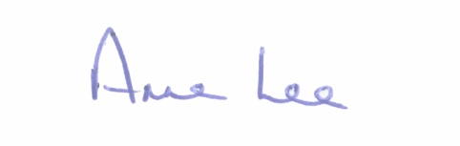
Yours sincerely,

___________________
Anne Lee,
Administrative Officer.
AGENDA

1. Confirmation of Minutes of Joint Policing Committee meeting held on the
3rd April 2017 - enclosed.

2. Matters arising.
3. Garda Report.
4. Local Authority Report.
5. Update on CCTV.
6. Longford Joint Action Plan.
7. Update on Crime Prevention Ambassador Programme.
8. Presentation by the Older Persons Council.
9. A.O.B.
10. Date of next meeting.

